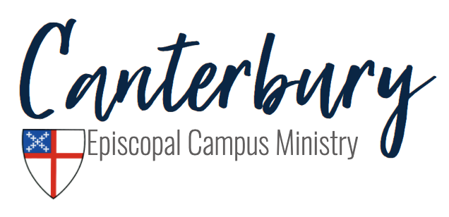
Fall 2022 Covid-19 Guidelines

Hi everyone! We are so excited to begin another semester with returning members and new members! We are following the guidelines of the diocese and the recommendations of the CDC and JMU. If you have any questions, comments, or concerns about the following guidelines, please feel free to reach out to anyone on Vestry. Please be aware that decisions may change given new information and health conditions in the area.

We are currently in a low transmission state, so:

- If you are not vaccinated, we ask you to please wear a mask inside, regardless of social distancing.
- Inside the building, masks are optional, and we will use social distancing as necessary.
- When we are outside, masks and social distancing will be up to the individual.
- During Holy Eucharist, the bread is served, wine will be available by intinction (dipping) only.
- Rides are provided. Please make sure that fresh air is circulating and windows rolled down/cracked weather permitting.
- Services will continue to be streamed on Facebook Live for those who are uncomfortable or unable to join us in person!
- High touch surfaces will be disinfected daily.
- Windows will be opened to allow fresh air into the building on a regular basis.

We are so excited to have everyone back for this 2022-2023 school year! As always, please be flexible as we might need to change these guidelines as JMU and the Episcopal Diocese of Virginia provide guidance. Check out our social media for upcoming event reminders! Again, if you have any questions, please feel free to reach out to Rev. Laura Lockey (minniclk@gmail.com) or anyone on Vestry. Stay safe!
